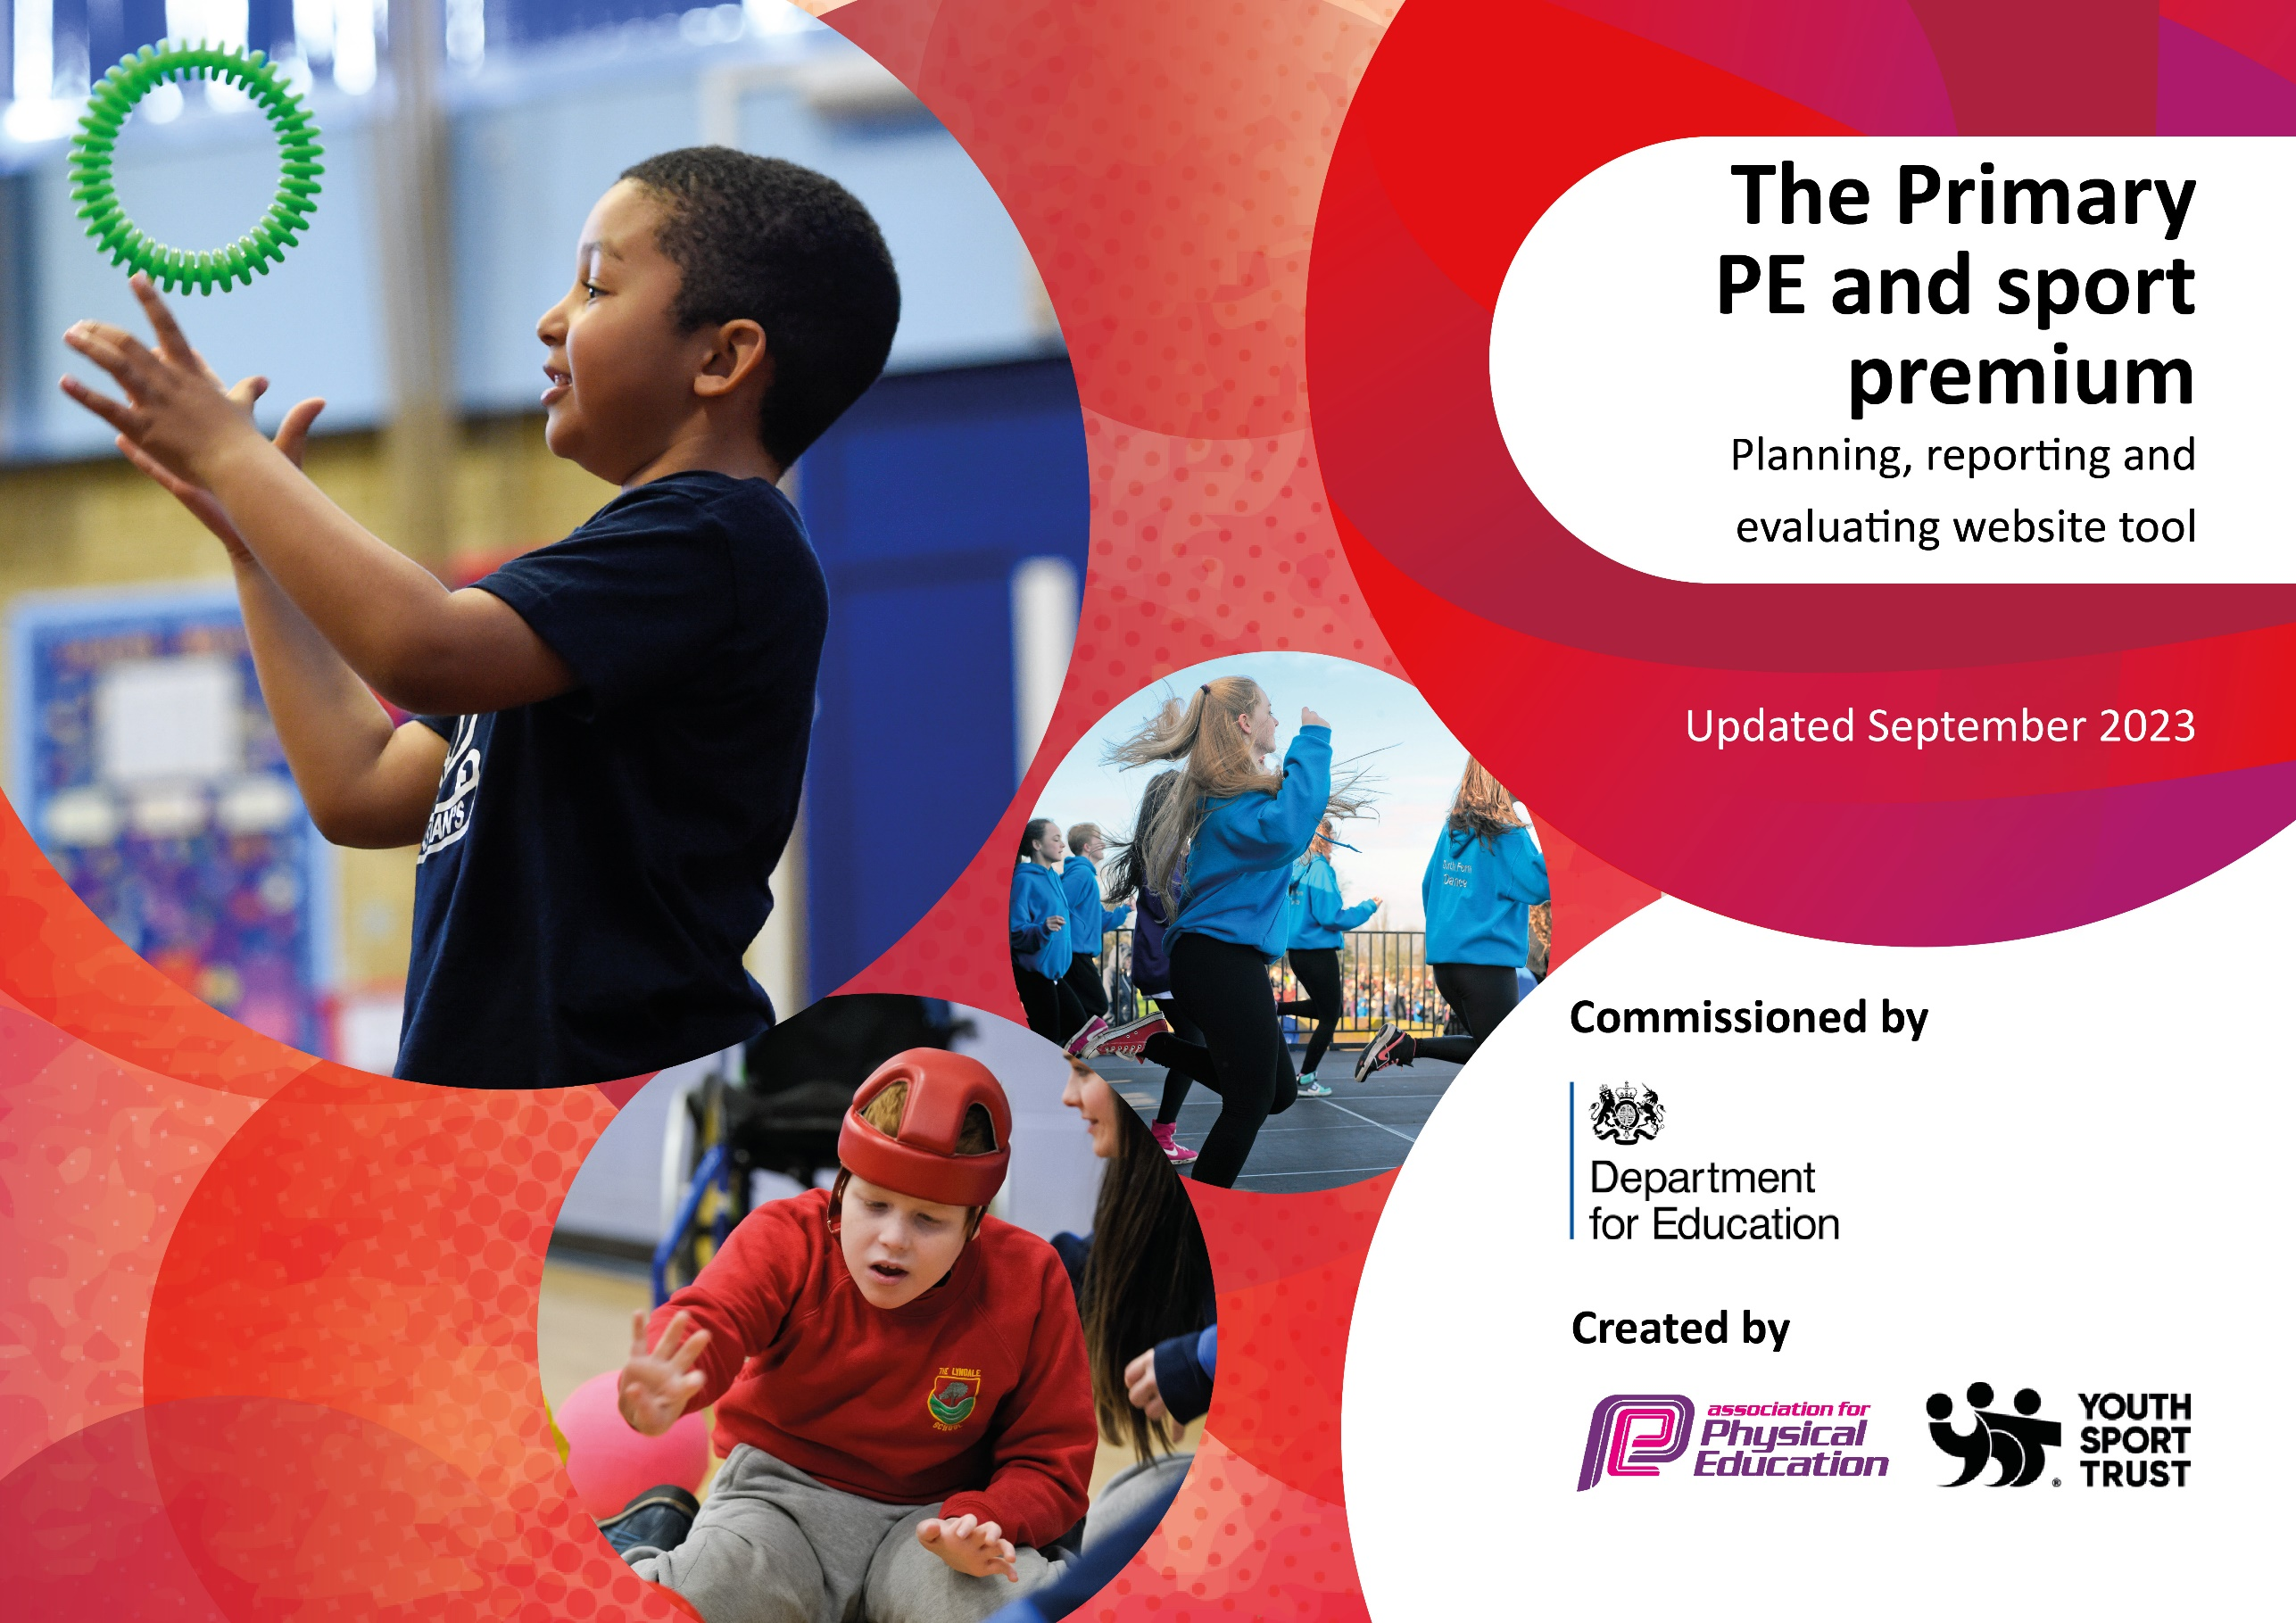

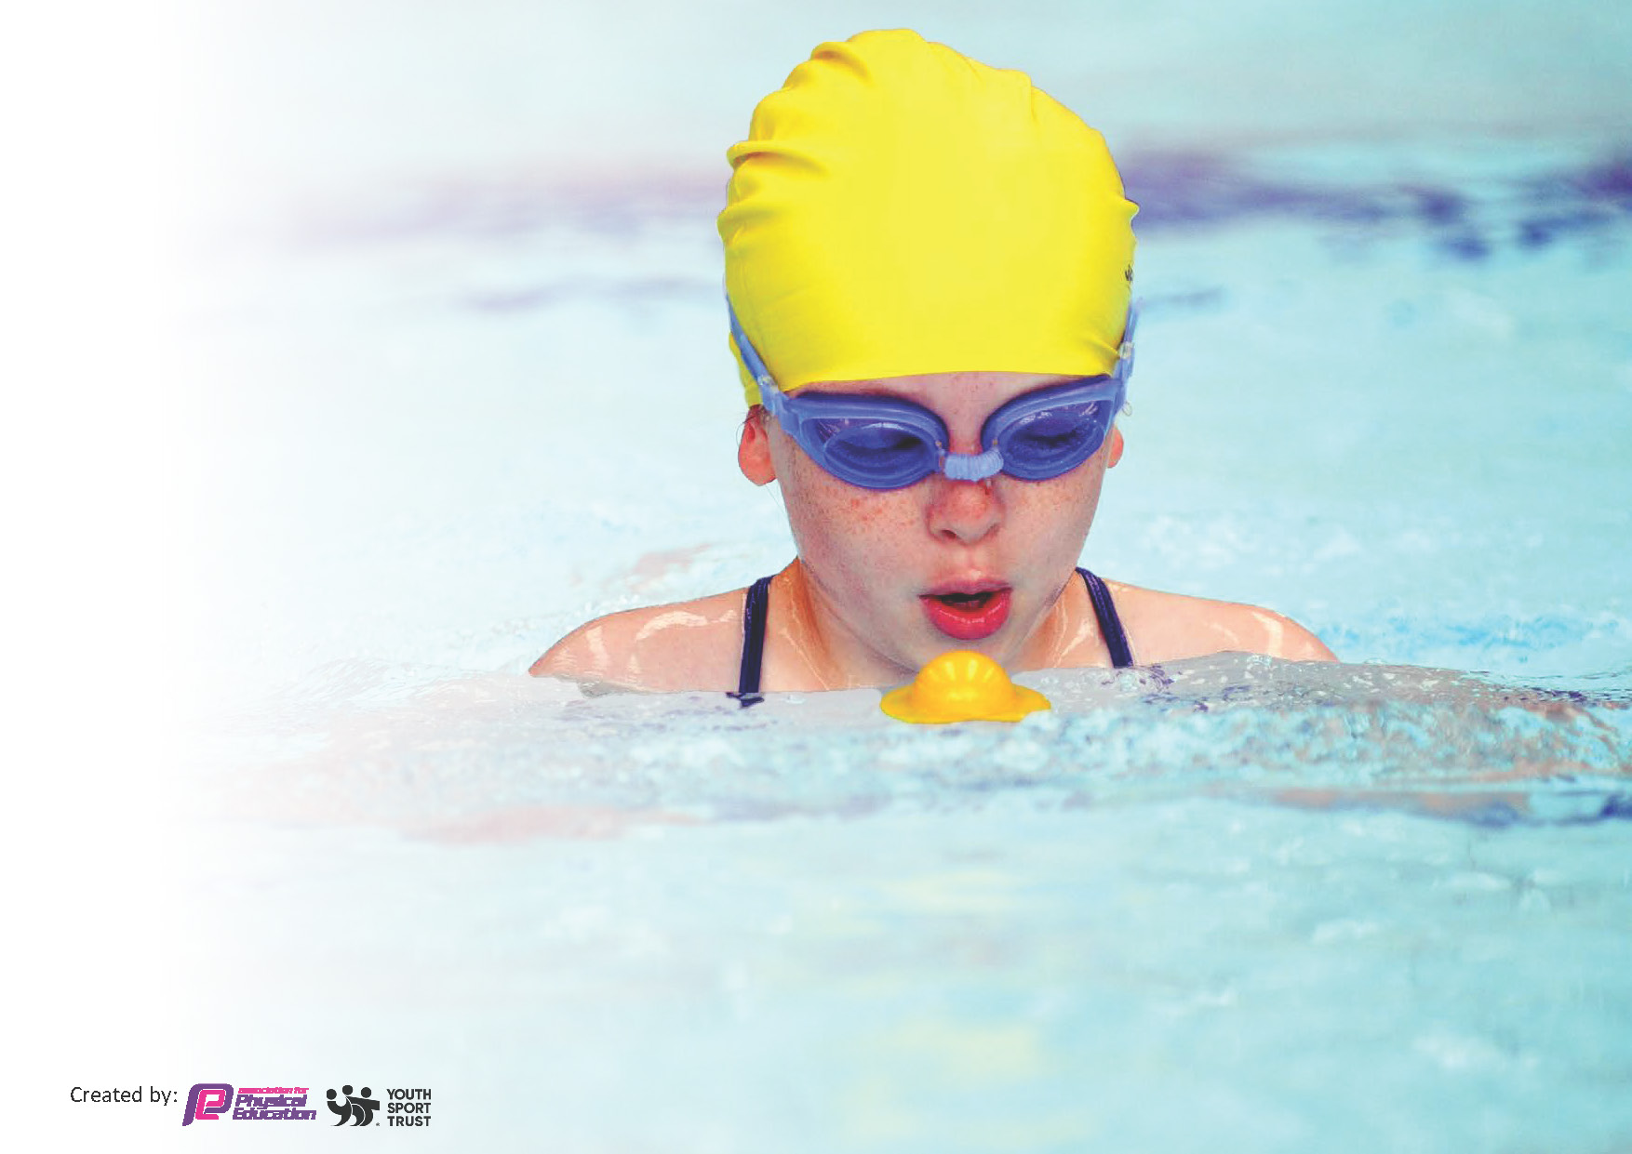
This template can be used for multiple purposes:
by:
- It enables schools to effectively plan their use of the Primary PE and sport premium
- It helps schools to meet the requirements (as set out in guidance) to publish information on their Primary PE and sport premium
- It will be an effective document to support Ofsted inspections enabling schools to evidence progress in Physical Education (PE) and evidence swimming attainment, which forms part of the PE National Curriculum. We would recommend schools consider
the Intent, Implementation and Impact of any spend, as examined within the Education Inspection Framework.

It is important that your grant is used effectively and based on school need.

Schools must use the funding to make additional and sustainable
improvements to the quality of the PE, School Sport and Physical Activity (PESSPA)
they offer. This means that you should use the Primary PE and sport premium to:

- Build capacity and capability within the school to ensure that improvements made now will benefit pupils joining the school in future years
- Develop or add to the PESSPA activities that your school already offers.

The Primary PE and sport premium should not be used to fund capital spend projects; the school’s core budget should fund these. Further detail on capital expenditure can be found in the updated Primary PE and sport premium guidance.

The Primary PE and sport premium guidance, outlines 5 key priorities that funding should be used towards. It is not

necessary that spending has to meet all the key priorities, you should select the priorities that you aim to use any funding towards.

Although completing this template is not a requirement for schools, schools are required to publish details of how they spend this funding. Schools must also outline what the impact this funding has had on pupils’ PE and sport participation and attainment and how any spending will be sustainable in the future. All funding must be spent by 31st July 2024.

The Department for Education has worked closely with the Association for Physical Education (afPE) and the Youth Sport Trust (YST) to develop this template and encourages schools to use it. This template is an effective way of meeting the reporting requirements of the Primary PE and sport premium.
Review of last year’s spend and key achievements (2022/2023)

We recommend you start by reflecting on the impact of current provision and reviewing your previous spend.

Activity/Action | Impact | Comments
Primary Stars PE delivery across the school (Every class has access to one term of Primary Stars PE) and staff CPD  GetSet4PE subscription  Swimming (Years 3 – 6)  Equipment purchased (goal posts, tennis balls, new bibs and football/netball kits, flood lights)  Visits from sports people- Professional basketball player and freestyle football workshops. A Paralympian- Nerys Pearce- visited and carried out workshops with all classes.  Equipment audited | Supporting staff and giving live feedback to staff during PE sessions. Shadowing lessons with PE specialists and supporting with behavior management during PE lessons.  The pupils gain high quality teaching from sports specialists and have access to a range of different sports.  PE scheme of work from EYFS through to Year 6 which shows clear progression of skills and knowledge. The EYFS Statutory Framework and Nation curriculum coverage. There are a range of teacher CPD and skills videos to support staff in delivering high quality sports lessons. There are useful resources for a subject lead to use.  Children should be able to swim 25m confident by the time they leave Year 6. The children need to be made equipped to enjoy swimming but also know how to stay safe in and around water.  More children during break times. All classes have their own ball and area to engage in physical activity.  Year 6 pupils participated in some inter-school competitions.  This has inspired more pupils to take part in after-school clubs and try new sports. | This has made a huge impact on the children receiving high quality teaching and PE delivery. The support and feedback for teachers has been able to help and provide a more sound knowledge of the PE curriculum.  This is an effective program and has been used to support staff CPD with particular units. The planning is clear and shows progression from EYFS up to Year 6.  All children leaving Year 6 can confidently swim 25m.  Plans to increase the level of competitive sport next academic year.  Have further visits/workshops from sports people (focus on female sporting role-models).

Key priorities and Planning
This planning template will allow schools to accurately plan their spending.

Action – what are you planning to do | Who does this action impact? | Key indicator to meet | Impacts and how sustainability will be achieved? | Cost linked to the action
Continue to develop staff CPD  To increase the pupils opportunities to take part in inter and intra school competitions.  Purchase tablets for staff and pupils to evaluate performance in PE.  Pupil premium children have the opportunity and are encouraged, to access extra-curricular sporting clubs.  To participate in National school sports’ week. | The teaching staff who are delivering PE lessons and the pupils who are in the lesson  Pupils in KS2.  Teachers of PE and pupils  Children in receipt of Pupil premium or from disadvantaged backgrounds.  All pupils | Key indicator 1: Increased confidence, knowledge, and skills of all staff in teaching PE and sport.  Key indicator 4: Boarder experience of a range of sport and activities offered to all pupils.  Key indicator 5: Increased participation in competitive sport.  Key indicator 1: Increased confidence, knowledge, and skills of all staff in teaching PE and sport.  Key indicator 2: The profile PE/SS/PA being raised across the school as a tool for whole school improvement.  Key indicator 4: Boarder experience of a range of sport and activities offered to all pupils.  Key indicator 4: Boarder experience of a range of sport and activities offered to all pupils. | Teachers to be confident in delivering effective PE supporting pupils to undertake extra activities inside and outside of school.  Relationships established with other schools/teams  School netball and football team created and training for younger pupils.  Pupils have the chance to represent their school in a range of sports.  Staff feel more confident teaching and assessing PE  The profile of PE is raised.  Children able to self-evaluate.  Pupil premium children are taking up the opportunity to engage in clubs they previously may not have had the opportunity to be part of.  Children get the chance to try new sporting activities and the importance of physical activity is promoted. | £2500  Primary Stars booked for every class for one term to support staff CPD.  Staff meetings allocated to PE and sport.  £500  Transport to events  Staff time for running training and fixtures  £8,000  Cost of purchasing tablets and software.  £1,000  Cost of attendance at clubs/training.  £3500  Book outside providers to run activities and workshops over the week.

All children should be able to swim 25m by the time they leave St Cath’s. | Year 6 children |  | All children will be able to swim 25m. | £250

Key achievements 2023-2024
This template will be completed at the end of the academic year and will showcase the key achievements schools have made with their Primary PE and sport premium spending.

Activity/Action | Impact | Comments
- Continue to develop staff CPD:  Primary Stars have taught every class for one term to support staff CPD in a range of sports including, games, athletics and ball skills. Teachers are present at these sessions and co-teach parts of the lesson.  Staff meetings have been held to support staff CPD. The area focused on this year was Dance.  Subject leaders have collaborated with PE leads from other schools in order to share best practice.  Subject leader has supported staff with the implementation of the PE curriculum and offered support CPD through lesson observations, feedback from pupil voice etc.  - Plan opportunities for pupils to take part in inter and intra school competitions.  A school football (girls and boys) and netball team (open to all pupils) have been established. They train weekly and have taken part in a wealth of fixtures over the academic year against schools in our local area and within our Trust.  Classes have taken part in competitive sport against each other in sports such as dodgeball, rounders etc.  - We participated in National school sports’ week.  All pupils came off timetable for the week and took part in a range of sports and physical activity. They had the chance to try new activities that they may have not taken part in before such as: climbing, aeroball, boccia, laser tag, curling aswell as dance, dodgeball. Pupils learnt about famous sportspeople and had the chance to come dressed as sporting role models. We have used the Euros and Olympics to learn about other countries etc.  - We have had a range of extra-curricular activities  Workshops held over the year include:  - Tri-golf  - Chance to Shine cricket  - Gaelic football  - PSD  - Chinese new year dance workshops  - African dance workshops  - Martial arts  - Disney musicals workshop  - Primary Stars  - The Outdoor company  - Mavericks netball  - Olympic mini day  - Mental health workshops- A-life and Positive Minds  - Irish dancing  - Swimming- life-saving  - ZKT dance club  - Year 5 and 6 trip- Watford FC stadium tour and workshops  - Tai-Chi  - Netball and football fixtures and tournaments  - External tennis provider  - Pupil premium children have the opportunity to access extra-curricular sporting clubs.  - Staff have become more confident and familiar with the Get set for PE material and planning.  - Continued to provide GetSet4PE as a resource to support high-quality PE lessons and implementing the curriculum.  - Resources to support the delivery of the curriculum have been replaced and enhanced. | The quality of teaching and learning in PE has increased. Teachers are aware of the expectations when delivering PE lessons. Staff feel more confident, particularly in the area of dance.  Subject leader feels more confident in leading PE and is secure in the vision for the subject and next steps to be taken to improve the quality of T&L.  Children have had the chance to represent their school at a range of fixtures/tournaments over the year in netball and football as well as competing in tournaments at Watford Football Club.  Pupil voice showed that the week was highly successful and the children got to have new experiences.  The children have experienced a huge range of sports over the year which has given the pupils a chance to experience a wider range of sports.  Pupils who may not have had the opportunity to attend physical activity clubs have had the chance to do so.  SL has provided teachers with development, mentoring & appropriate resources to help them teach PE and sport more effectively to all pupils and embed physical activity across the school.  Staff are equipped to deliver high quality physical education. Assessment and CPD is supported through the Get Set scheme.  We have purchased:  • Mats for use in dance/gymnastics (£1700)  • Ribbons for teaching dance  • Rubber footballs for the playground  • Tennis balls  • Hoops  • Netballs  • Netball bibs  • A storage shed  • Goalkeeper gloves  • Resources for sports’ day  • Playground and field markings | All staff have better understanding of the curriculum and what needs to be included in a high quality lesson.  Primary Stars are going to deliver further CPD sessions in the Autumn term to all teachers.  Our pupils have embraced the opportunities fully and we have received positive feedback about their conduct and behaviour. We are keen to continue and extend these opportunities next year and look into opportunities for our pupils to compete in other sports i.e. running or athletics.  This will be repeated next year and planning will start in September. Different activities will be booked. There will be more opportunities for children to compete against each other in a range of sports.  The PE lead will continue to engage with and promote extra-curriculuar activitiesto all pupils through workshops/external companies and information/fliers to parents.  School will continue to prioritise providing access to clubs for PP children.  Continue to share and promote the use of the Get Set for PE materials. Carry out monitoring to evidence this including looking at planning and lesson walks.  Termly review of equipment and staff voice to identify and areas where we need to purchase new equipment or replace lost/damaged resources.

Swimming Data
Meeting National Curriculum requirements for swimming and water safety.
Priority should always be given to ensuring that pupils can perform safe self-rescue even if they do not fully meet the first two requirements of the National Curriculum programme of study

Question | Stats: | Further context  Relative to local challenges
What percentage of your current Year 6 cohort can swim competently, confidently and proficiently over a distance of at least 25 metres? | 76%
What percentage of your current Year 6 cohort can use a range of strokes effectively [for example, front crawl, backstroke, and breaststroke]? | 76%

What percentage of your current Year 6 cohort are able to perform safe self-rescue in different water-based situations? | 100% | All Year 6 children carried out a block of water-safety lessons in the summer term.
If your schools swimming data is below national expectation, you can choose to use the Primary PE and sport premium to provide additional top-up sessions for those pupils that did not meet National Curriculum  requirements after the completion of core lessons. Have you done this? | Yes/No | We provided top up swimming for some pupils in the summer term. We plan to do the same in 2025.
Have you provided CPD to improve the knowledge and confidence of staff to be able to teach swimming and water safety? | Yes/No | Our swimming lessons are delivered by qualified instructor at our local pool.

Signed off by:

Head Teacher: | Nicola Kane
Subject Leader or the individual responsible for the Primary PE and sport premium: | Steph Taylor (AH) and Rebecca Richardson (CT)
Governor: | Adanta Anderson
Date: | 02.07.24

